If you want to use this paper during the online exam I recommend downloading it beforehand. It might technically be interpreted as communication between us if multiple people access it during the exam.

Exercise 1

a)

P1 || P2

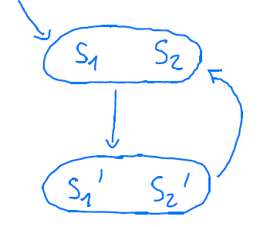

Answer from Rafael
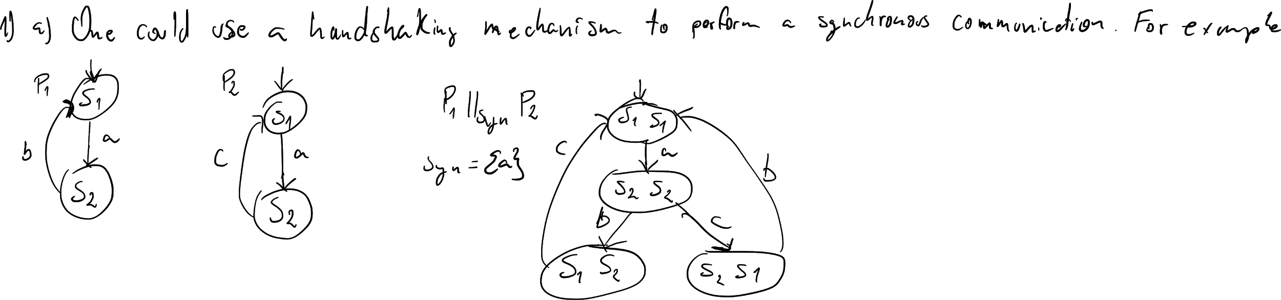

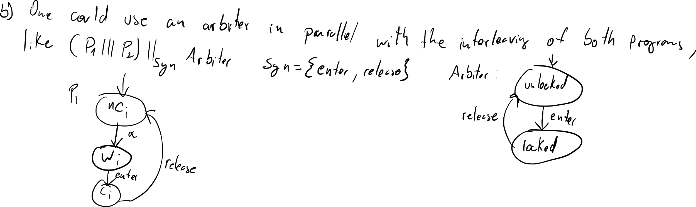

b)

P1 ||| P2

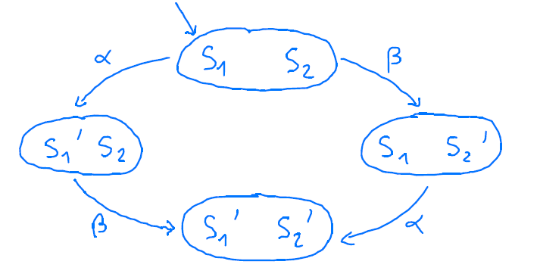

Answer from Rafael

c)

P1 P2

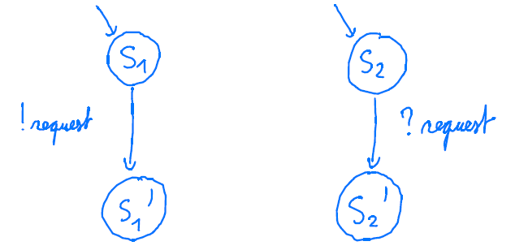
Answer from Rafael:
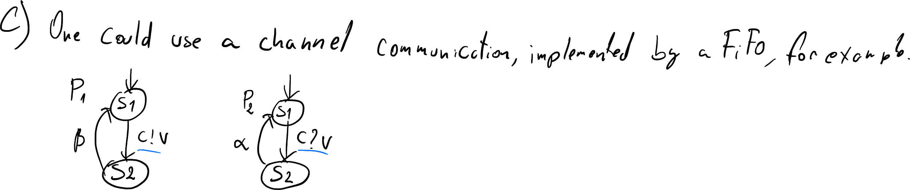

Exercise 2
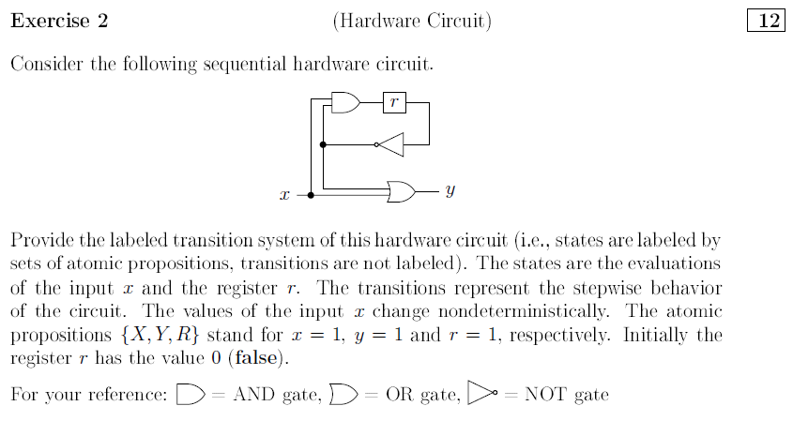

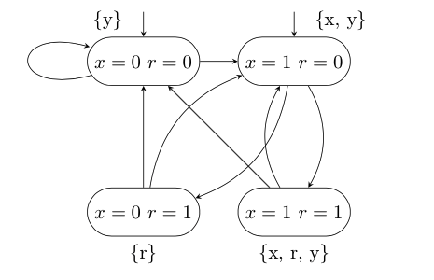

Exercise 3

red1
green1
alpha1
beta1
TS1

red2
green2
alpha2
beta2
TS2

b)

r1, r2
g1 , g2
alpha1
alpha2
TS1 || TS2

r1, g2
g1, r2
alpha2
alpha1
beta1
beta2
beta2
beta1

c)

lock
alpha1
alpha2
TS0

unlock2
unlock1
beta1
beta2

d)

r1, r2, l
alpha1
alpha2
TS0 || (TS1 || TS2)

r1,g2,u2
g1,r2,u1
beta1
beta2

e)
The traffic lights have no synchronization between themselves.

Exercise 4
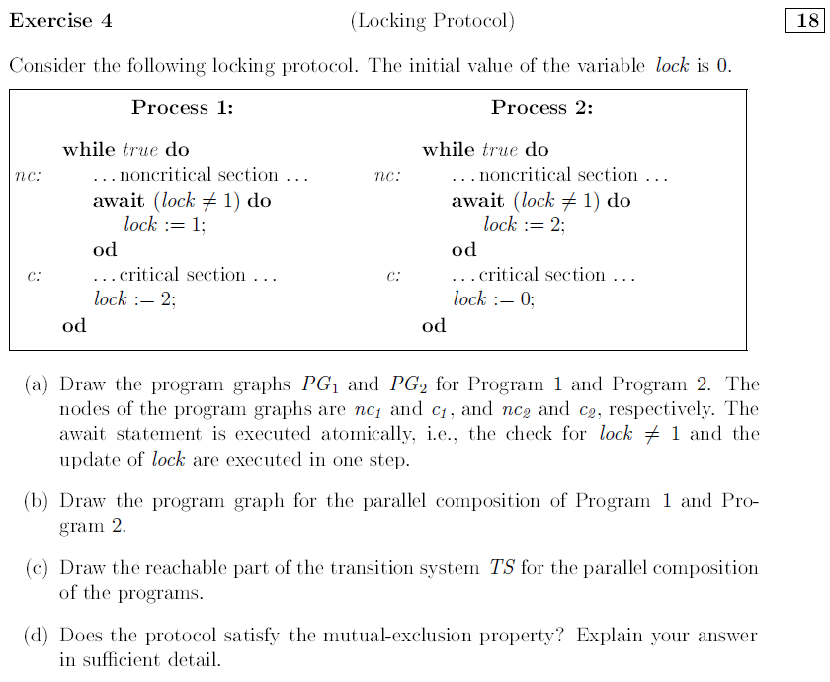

a)
PG1: PG2:

ncrit1

crit1
lock = 1
lock = 2

ncrit2

crit2
lock = 2
lock = 0

b)
PG1 ||| PG2:

n1, n2

c1, c2
lock = 1
lock = 2

c1, n2

n1,c2
lock = 1
lock = 2
lock = 2
lock = 0
lock = 0
lock = 2
c)
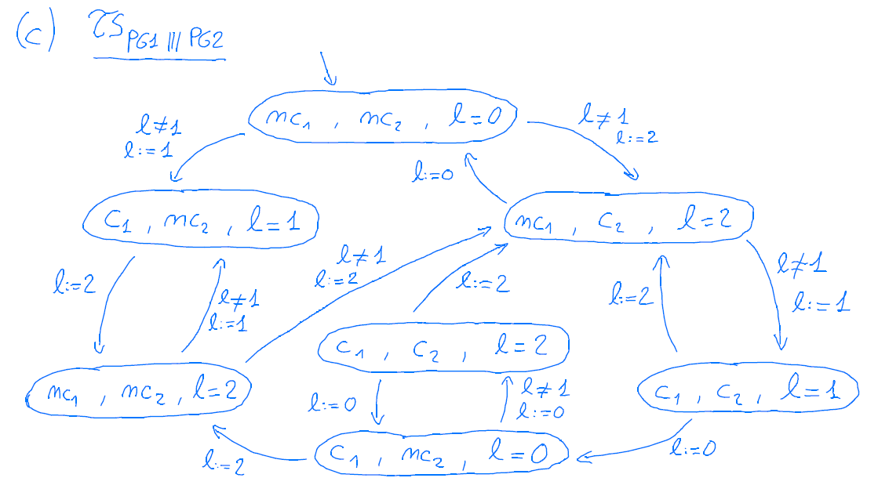

d) No, because there is a reachable state, where both processes are in their critical section

Exercise 5
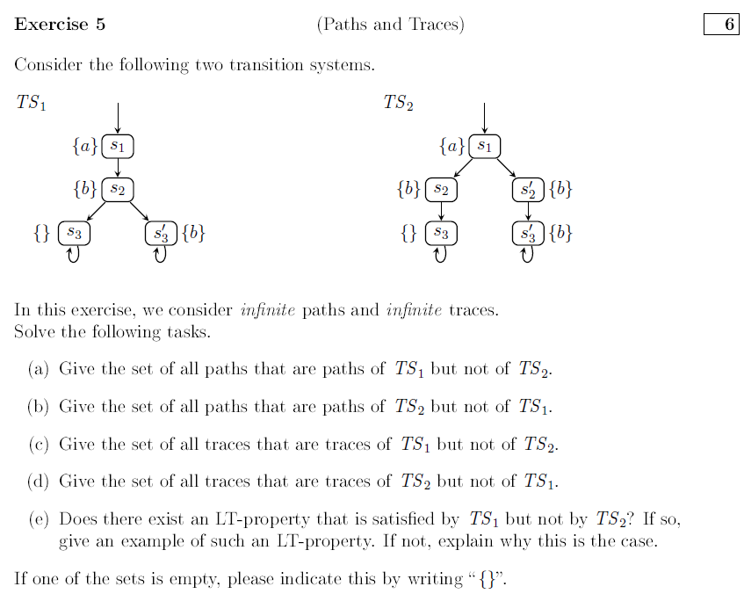

- $paths(TS_{1}) \backslash (TS_{2}) = {\{s}_{1} s_{2} {{(s'}_{3})}^{ω}\}$
S₁ S₂ (S₃’)^{ω}

- $paths(TS_{2}) \backslash (TS_{1}) = {\{s}_{1} {s'}_{2} {{(s'}_{3})}^{ω}\}$
S₁ S₂’ (S₃’)^{ω}

- {}

- {}

- No. There are no traces which are only in either TS1 or TS2.
For all Properties P: TS1⊧P ↔TS2⊧P

Exercise 6
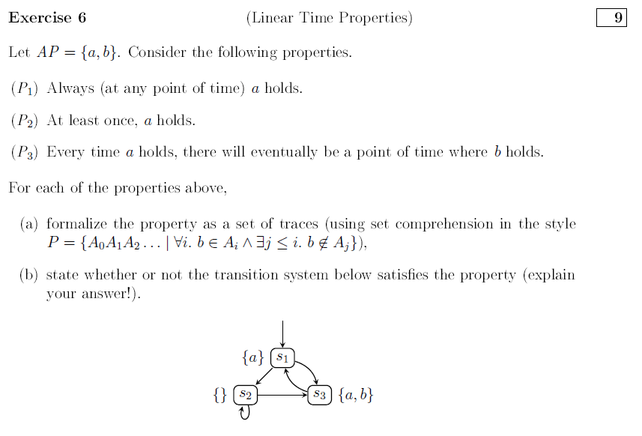
a)
$P_{1} = \{A_{0}A_{1}...| ∀i. a ∈ A_{i}\}$
$P_{2} = \{A_{0}A_{1}...| |\{i| a∈A_{i}\}≥1\}\}$
$P_{3} = \{A_{0}A_{1}...| ∀i. a ∈A_{i }→ ∃j>i. b ∈A_{j}\}$

b)
P1: No, s2 does not hold
P2: Yes
P3: No. s1 → s2^w

Exercise 7
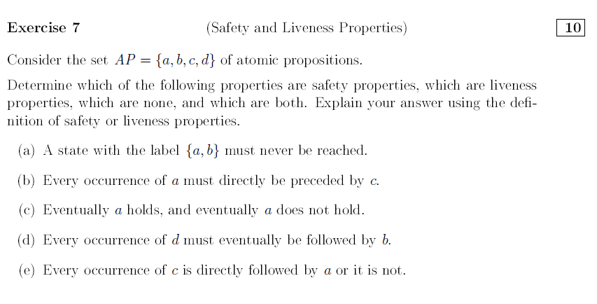
- Safety Property: Because we can define the set of bad prefixes as follows:
$BadPref(P_{1}) = \{A_{0}A_{1}A_{2}...A_{n}|∀i≤n. a∈A_{i} and b∈A_{i} and c∉A_{i} and d ∉A_{i} \}$
Not a liveness property: Because there exists a bad prefix $π=\{a,b\}$
- Safety Property: $BadPref(P_{2}) = \{A_{0}A_{1}A_{2}...A_{n}|∀i ≤ n. a∈A_{i} → c∉A_{i-1} \}$
Not a liveness property: Because there exists a bad prefix $π=\{b\}\{a\}$
- Not a safety property: Because $σ=\{b,c\}^ω$doesn’t satisfy the property because a never holds, but it also doesn’t have a bad prefix
Liveness property: Because an arbitrary word $w∈2{^}^{AP}$can be extended to $w\{a\}(\{\})^ω∈P_{3}$
- Not a safety property: Because $σ=\{d\}^ω$doesn’t satisfy the property, but it also doesn’t have a bad prefix
Liveness property: Because an arbitrary word $w∈2{^}^{AP}$can be extended to $w\{b\}^ω∈P_{3}$
- Safety Property: Because the property is even an invariant. $Φ=true$
Liveness property: Because every trace is accepted.

Exercise 8
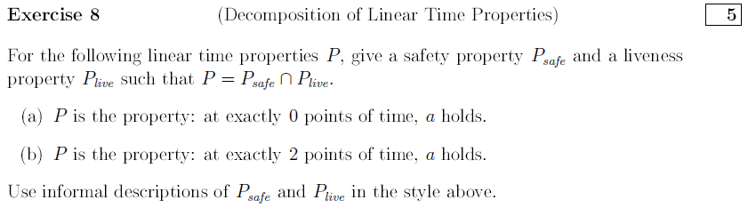

- $P_{safe}= cl(P)=\{A_{0}A_{1}...| ∀i . a∉A_{i}\}=P$
$P_{live}= P∪(( {2_{}}^{AP}) {}^{ω} \backslash cl(P))=P∪(( {2_{}}^{AP}) {}^{ω} \backslash P))=$$( {2_{}}^{AP}) {}^{ω}$

OR
$P_{safe}$is the property: a never holds
$P_{live}$is the property: true

- $P_{safe}$is the property: a holds at most 2 times
$P_{live}$is the property: a holds at least 2 times

Exercise 11
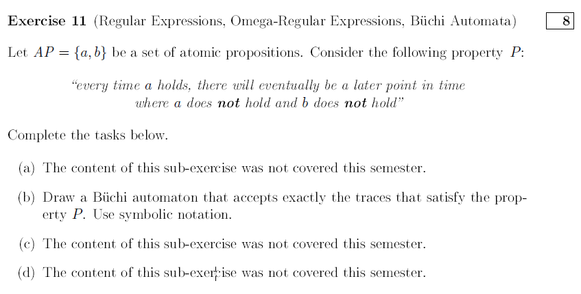
b)
{b, {} }
{a}

{a,b}
{}

Exercise 12
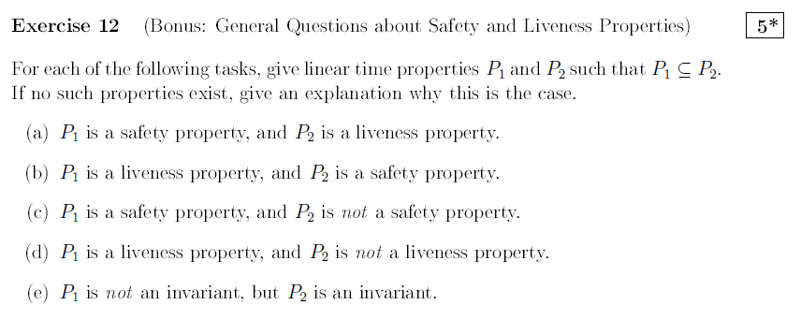

- $ϕ_{P1}=∀i. (A_{2i} = \{a\} ∧ A_{2i+1}= \{b\})$ alternating a,b
$ϕ_{P2}=∀i. a∈A_{i} →∃j>i.b∈A_{j+1}$ eventually, b follows after any a
- $ϕ_{P1}=$true
$ϕ_{P2}=$true
- $ϕ_{P1}=∀i. a∈A_{i}$
$ϕ_{P2}=|\{i|a∈A_{i}\}| ≥0$
- $ϕ_{P1}=∀i. a∈A_{i}→∃j>i.b∈A_{j}$
$ϕ_{P1}=a ∨b$
- Don’t think this is possible. A subset P1 of a property P2 still has to be valid for P2.

